2026 SHED MOCK MATHEMATICS PAPER I
PROVISIONAL MARKING KEY

- $2+5d-{12d}^{2}$
$=(2+8d)-(3d-12d^{2})$ M1
$=2\left(1+4d\right)-3d\left(1+4d\right)$ M1
$=(2-3d)(1+4d)$ A1
OR
= −12d² + 5d + 2
−12 × 2 = −24
= −12d² + 8d − 3d + 2 M1
=−4d(3d − 2) −1(3d − 2) M1
= (−4d − 1)(3d − 2) A1

SOLUTION

$\frac{1}{2}$ $M$ = $\frac{1}{2}$ $\left[\begin{matrix}8 & 2 \\ 0 & 4\end{matrix}\right]$
=$\left[\begin{matrix}\frac{1}{2} ×8 & \frac{1}{2} ×2 \\ \frac{1}{2} ×0 & \frac{1}{2} ×4\end{matrix}\right]$ M1
=$\left[\begin{matrix}4 & 1 \\ 0 & 2\end{matrix}\right]$ M1
$N^{2}$ = $\left[\begin{matrix}2 & 1 \\ 0 & 1\end{matrix}\right]×\left[\begin{matrix}2 & 1 \\ 0 & 1\end{matrix}\right]$
=$\left[\begin{matrix}2×2+1×0 & 2×1+1×1 \\ 0×2+1×0 & 0×1+1×1\end{matrix}\right]$ M1
= $\left[\begin{matrix}4 & 3 \\ 0 & 1\end{matrix}\right]$ M1
$\frac{1}{2}$ $M$ - $N^{2}$ = $\left[\begin{matrix}4 & 1 \\ 0 & 2\end{matrix}\right]$ - $\left[\begin{matrix}4 & 3 \\ 0 & 1\end{matrix}\right]$
= $\left[\begin{matrix}4-4 & 1-3 \\ 0-0 & 2-1\end{matrix}\right]$ M1
= $\left[\begin{matrix}0 & -2 \\ 0 & 1\end{matrix}\right]$ A1

- $\frac{2}{\sqrt{5}+1}= \frac{2}{\sqrt{5}+1} ×\frac{\sqrt{5}-1}{\sqrt{5}-1}$ M1
$= \frac{2\sqrt{5}-2}{5+\sqrt{5}-\sqrt{5}-1}$M1
= $\frac{2\sqrt{5}-2}{5-1}$ M1
$=\frac{2(\sqrt{5} -1)}{4}$
$=\frac{ \sqrt{5}-1}{2}$M1 A1

Sketch

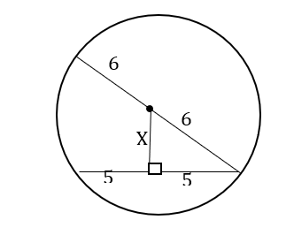

Let the distance from the centre to the chord be ‘x’
$x^{2}+ 5^{2}= 6^{2}$ (Pythagoras) M1
$x^{2}=36-25$ M1
$\sqrt{x^{2}}= \sqrt{11}$ M1
$x= \sqrt{11}$ cm or 3.32 cm (to 2 d.p.) M1 A1

- Total number of balls in the bag=14 M1
Pr(white or red)$=\frac{6}{14}+\frac{7}{14}$ M1 M1
$=\frac{13}{14}$ M1 A1

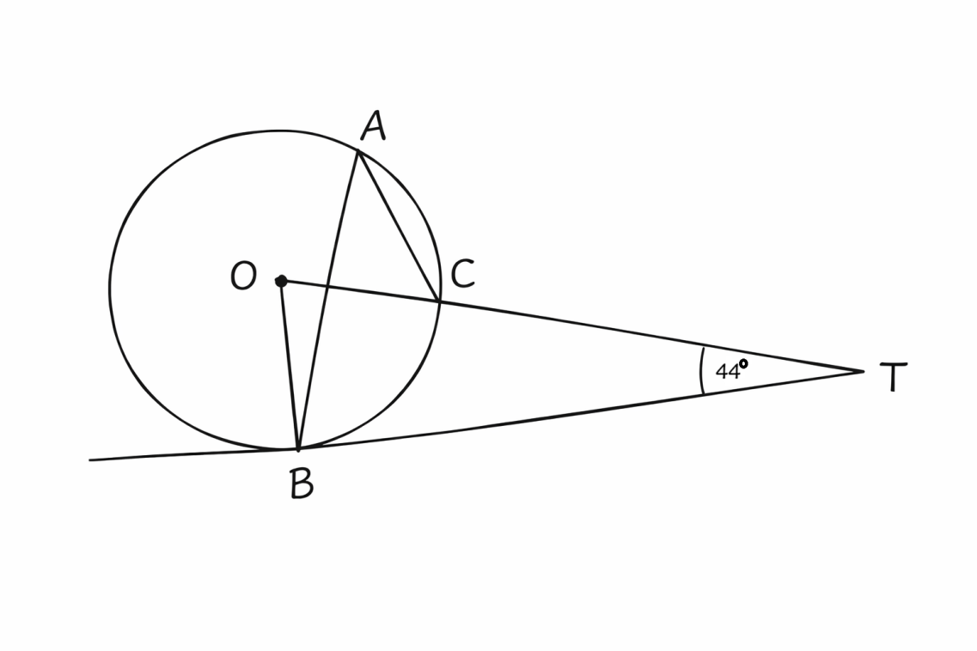
Figure 1
$angle OBT=90° (\tan{per. to radius})$ M1
$angle BOT=180°-44-90° (sum angles of a triangle)$ M1
$angle BOT=46°$ M1
$angle BAC=\frac{46°}{2}$ (Angle at the centre = twice at the circu.) M1
$angle BAC=23°$ A1

$$Area ratio=\frac{Area of BCD}{Area of XYZ}$$
$=\frac{100}{256}$
= $\frac{25}{64}$ M1
L.S.F = $\sqrt{\frac{25}{64}}$
= $\frac{5}{8}$ M1
$$\frac{BC}{XY}= \frac{5}{8}$$
$\frac{BC}{16}= \frac{5}{8}$ M1
$BC= \frac{5}{8} ×16$ M1
BC= 10 cm A1

- Midpoint of a vector = $\frac{x_{1}+x_{2}}{2}, \frac{y_{1}+y_{2}}{2}$
= $\left(\frac{6+(-4)}{2}, \frac{4+2}{2}\right)$ M1
= $\left(\frac{6-4}{2}, \frac{4+2}{2}\right)$ M1
= $\left(\frac{2}{2}, \frac{6}{2}\right)$ M1
= $\left(1, 3\right)$ A1
- Surface area $=πrl+πr^{2}$
= $(\frac{22}{7} ×7 ×21) +(\frac{22}{7} ×7 ×7)$ M1M1
= $462 ×$ 154 M1
= $616{cm}^{2}$ M1 A1
- Volume of a hemisphere = $\frac{1}{2 } ×\frac{4}{3}πr^{3}$
= $\frac{1}{2 }×\frac{4}{3 }×\frac{22}{7} ×6 ×6 ×6$ M1
${= 452.57m^{3}}^{}$ M1
Volume of a cylinder = $πr^{2}h$
$452.57= \frac{22}{7} ×5 ×5×h$ M1
$7×452.57= \frac{22}{7} ×5 ×5×h×7$
$\frac{3167.99}{550} = \frac{550h}{550}$ M1
$h = 5.76m$ M1A1

- $ar=10 (1)$
$$ar^{4}=640 (2)$$
$\frac{ar^{4}}{ar}$ =$\frac{640}{10}$ M1
$${ r}^{3} =64$$
$$r =\sqrt[3]{64}$$
$r =4$ M1
$$ar=10$$
$$a\left(4\right)=10$$
$a=2.5$ M1
$$s_{n}=\frac{a\left(r_{-1}^{n}\right)}{r-1}$$
$s_{5}=\frac{2.5\left({4 }_{- 1}^{5}\right)}{4-1}$ M1
$$s_{5}=\frac{2.5\left(1024-1\right)}{3}$$
$s_{5}=\frac{2.5\left(1023\right)}{3}$ M1
$$s_{5}=\frac{2557.5}{3}$$
$s_{5}=852.5$ A1

- $\left(4x^{2}-9\right)\left(mx+d\right)≡$ $16x^{3}+24x^{2}-9xm-54.$
$4mx^{3}+4{dx}^{2}-9mx- 9d≡$ $16x^{3}+24x^{2}-9xm-54.$ M1
$4m =16$ M1
$m = \frac{16}{4}$ M1
$m=4$ A1
$$- 9d = -54$$
$d= \frac{-54}{-9}$ M1
d = 6 A1

- $Mean =\frac{\sum{fx}}{\sum{f}}$
=$\frac{(14×3) +(15×4) + (16×5) + (17×4)}{3 +4 +5 +4}$ M1
=$\frac{42 +60 + 80 + 68}{16}$ M1
= $\frac{250}{16}$
=15.625 M1 M1
=15.6 (to 1 d.p) A1

$\frac{a- 2 }{2a-3} = \frac{5 }{7}$ M1
$$7(a-2) =5(2a-3)$$
$7a -14 =10a -15$ M1
$$-14+15 =10a -7a$$
$1=3a$ M1
$a=\frac{1}{3}$ A1

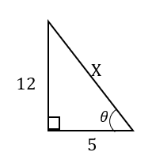
$x^{2}={12}^{2}+5^{2}$ (Pythagoras theo.) M1
$$x^{2}=144+25$$
$$\sqrt{x^{2}}=\sqrt{{169}^{}}$$
$x = 13$ M1
$\frac{\sin{θ + 2\cos{θ}}}{1 - \sin{θ}} = \frac{\frac{12}{13}+2\left(\frac{5}{13}\right)}{1-\frac{12}{13}}$ M1
= $\frac{\frac{12}{13}+\frac{10}{13}}{\frac{1}{13}}$ M1
=$\frac{22}{13}÷\frac{1}{13}$
=$\frac{22}{13}×\frac{13}{1}$
= 22 M1 A1

- X(3,0), Y(2,-3) and Z(5,-4) translated to X’(1,3), Y’(0,0) and Z’(3,-1) M1
Column vector X + translation vector = position vector X’
$\left({3 \atop 0}\right)$ + $\left({x \atop y}\right)$= $\left({1 \atop 3}\right)$ M1
$\left({x \atop y}\right)$ = $\left({1 \atop 3}\right)- \left({3 \atop 0}\right)$ M1
$\left({x \atop y}\right)$ = $\left({-2 \atop 3}\right)$ A1

- a
$$p∝\frac{q}{\sqrt[3]{r}}$$
$p= \frac{kq}{\sqrt[3]{r}}$ (k is constant) M1
$10= \frac{5k}{\sqrt[3]{8}}$ M1
$2×10= \frac{5k}{2} ×2$
$20=5k$
$k= \frac{20}{5}$
K = 4 M1
$p= \frac{4×54}{\sqrt[3]{27}}$ M1
$$p= \frac{216}{3}$$
$p=72$ A1

Distance= $\frac{1}{2 } (sum of// sides)×h$
7200= $\frac{1}{2 } (60+120)×V$ M1 M1
7200= $\frac{1}{2 } (180)×V$
$$V= \frac{7200}{90}$$
$V=80m/s$ M1
$$a= \frac{v-u}{t}$$
$a= \frac{80-0m/s}{40s}$
$a=2m/s^{2}$ A1

$A= \frac{1}{2 }m (v^{2}- u^{2})$
$2×A= 2×\frac{1}{2 }m (v^{2}- u^{2})$
$\frac{2A}{m}= \frac{m (v^{2}- u^{2})}{m}$ M1
$$\frac{2A}{m}= v^{2}- u^{2}$$
$u^{2}= v^{2}- \frac{2A}{m}$ M1
$$\sqrt{u^{2}}=\sqrt{v^{2}-\frac{2A}{m}}$$
$u= \sqrt{v^{2}-\frac{2A}{m}}$ M1 A1

- $y≤0$
$y=0$ line
$$x+y<10$$
$x+y = 10$ line M1
x | 0 | 10
y | 10 | 0

$x-2y≥0$ .
$x- 2y = 0$ line M1
x | 0 | 4
y | 0 | 2

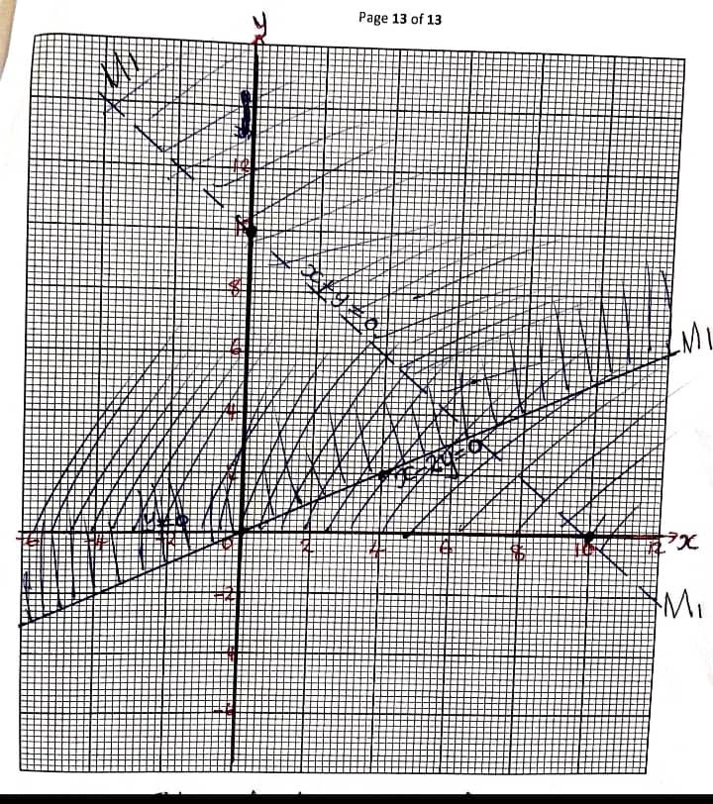
Drawing of line y = 0 M1
Drawing of line x + y = 0 M1
Drawing of line x - 2y = 0 M1

